TCI interface is defined using ASN.1.

ASN.1 files are saved in the

<https://github.com/certificationoperatingcouncil/TCI_ASN1/tree/master/TCI%20Interface/ASN1>

In order to download ASN.1 to your local computer go to

<https://github.com/certificationoperatingcouncil/TCI_ASN1>

and click on **Download ZIP** button

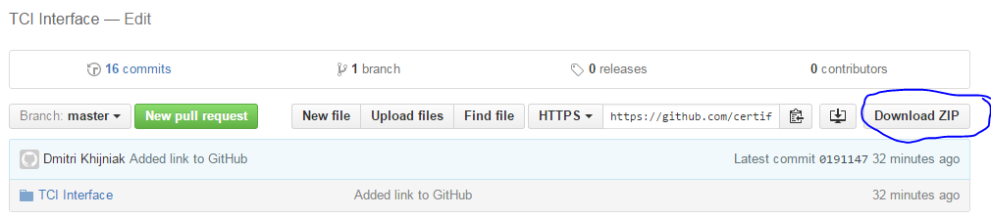

**While the TCI specification is in early draft form, please do not forward these links to others**